JM Hammond

**Cubism in Japan**

Japan was the first country in Asia to adopt Cubism. Word spread through articles in the popular press, in various Japanese art journals that sprung up during the 1910s, and via European texts appearing as Japanese translations. Key moments include a two-part report sent from Paris discussing the Cubist works at the Salon Des Independents exhibition, printed in a leading newspaper in July 1911, and a Japanese edition of Gleizes and Metzinger’s *Du Cubisme* in 1915. However, the unsatisfactory quality of the black and white reproductions of the period made it difficult for many to distinguish Cubism from other emerging forms of European modern art. This was exacerbated by both the lack of opportunities to see Cubist works in the flesh and their presentation alongside examples of other imported Modernist styles when works were shown in Japan. Exemplifying this situation was a 1914 exhibition of woodblock prints from Berlin’s Der Sturm art gallery, which displayed a small number of Cubist and Futurist works amongst the gallery’s mainstay of Expressionist art. In this climate, Japanese artists freely experimented with, and blended together, ideas from a variety of sources to suit their needs.

One of the first works in Japan to display some Cubist tendencies was Tetsugorō Yorozu’s (1885- 1927) *Self Portrait with Red Eyes* (1912). Yet, is equally as Expressionistic or Fauvist in its color choices and energetic brushwork, as it is Cubist in its jagged, faceted planes. It was also described as Futurist, as was Togo Seiji’s (1897-1978) *Playing the Contrabass*, although some contemporary critics recognized the Cubist credentials of this 1915 work. The following year, Togo fragmented the contours of the titular figure of *Woman With a Parasol* into a surrounding space of dynamically fractured curvilinear shapes, quite at odds with the typically angular lines of many Cubist works.

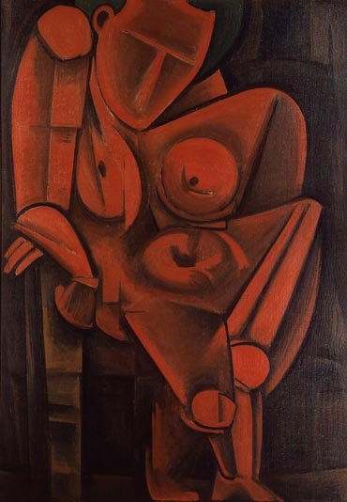

Tetsugorō Yorozu, *Leaning Woman* (1917),oil on canvas**,** Tokyo National Museum of Modern Art

The rise of exhibitions organized by artist groups helped spread awareness of the new idiom. Yorozu’s *Leaning Woman* caused a sensation at the Nika-kai exhibition of 1917 and is often considered the first truly Cubist work in Japan. Yet, studies leading up to this monumental workreveal how Yorozu utilized Cubist techniques to help find a solution to the problem of representing the human figure in two dimensions that had preoccupied him for a number of years. In this regard, Cubism was not simply copied wholesale but played a significant part in the fervent experimentation of the period.

In the mid-late 1920s many Japanese artists returned from studying in Paris and a more rounded understanding of Cubism emerged in Japan. One of these was Kuroda Jutaro (1887-1970), who attempted to popularize in Japan a neo-Classical take on Cubism he had learned from André Lhote (1885-1962). Sakata Kazuo (1889-1956), perhaps the most Cubist of the Japanese contingent, returned from France in 1929, where he had studied under Fernand Léger (1881-1955). Cubism had to lay low in the 1930s when avant-garde ideas were treated with suspicion, but emerged again after the war as another tool at the disposal of Japanese artists.

**References and Further Reading**

Otani, Shogo. “Cubism and Japan”in *Cubism in Asia – Unbounded Dialogues* Tokyo: National Museum of Modern Art, Tokyo, Japan Foundation, 2005

Volk, Alicia. *In Pursuit of Universalism: Yorozu Tetsugorō and Japanese Modern Art.* Berkley: University of California Press, 2010